**Recommendations for Big Mountain Resort to Regain the Profit Margin**

# **Introduction**

Big Mountain Resort is located in the northwestern Montana was opened in the year 1947 which offers spectacular views of Glacier National Park and Flathead National Forest. The resort observed an annual snowfall of 333 inches in 1947 and initially has 3000 acres of skier and rider accessible terrain. Big Mountain Resort offers access to 105 named trails and vast bowl and tree skiing. All these are serviced by 11 lifts, 2 T-bars and 1 magic carpet for novice skiers. The longest run is named Hellfire and is 3.3 miles in length. The base elevation is 4,464 feet, and the summit is 6,817 feet with a vertical drop of 2,353 feet. The mountain can accommodate all levels of skiers and riders since the terrain has rating of 12% beginner, 38% intermediate, 44% advanced and 6% expert. Every year about 350,000 people ski or snowboard.

This year the resort has installed an additional chairlift which has increased their operational cost by $ 1,540,000. The investors have raised the concern for this increased cost and do not want to compromise on the profit margin of 9.2%. Hence, the management wants recommendations to keep the profit margins same and in addition they also want to know about the expected revenue in the upcoming season.

# **Initial Recommendations**

The data provided for analysis consist of information of 330 resorts with 27 parameters with some parameters like region, elevation, vertical drop, skiable area etc. as fixed parameters and others like no. of runs of lifts, cost of tickets, projected open days as variables. Hence the scope of solution will be getting the recommendations for these variable parameters especially:

1. No. of runs on the resort
2. Projected days open in the upcoming season
3. Cost of an adult weekday chair lift ticket
4. Cost of an adult weekend chair lift ticket

# **Modelling Results and Analysis**

Initially the analysis has been focused on predicting the optimum price of ticket for an adult at weekend. Linear Regression have been chosen for modelling the parameters and the results of analysis have been discussed below:

Given the dataset and after removing the outliers, data of 164 resorts have been retained which are then divided into 3 clusters based on the parameters. Big Mountain resort is classified as cluster 3 as can be seen from the figure below:

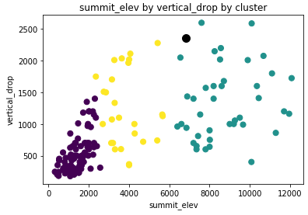

Figure 1: Cluster Classification of Resorts

The results indicate that the price of a ticket at weekend depends majorly on the summit elevation, price of ticket at weekdays, no. of days report was open in the last year and no. of days resort is being projected to open for this season. The graphs with few of these parameters are given below

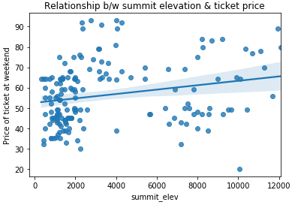 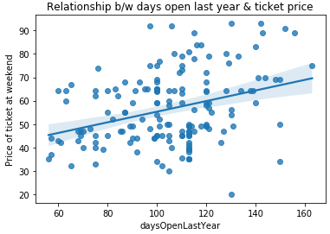

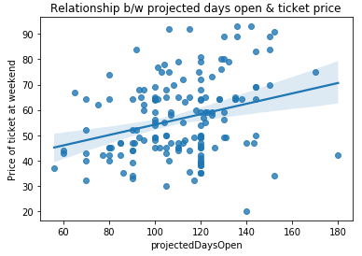

Figure 1: Relationship between various parameters and price ticket

The optimum price as predicted from the model for Big Mountain Resort for an adult at weekend is $103 as compared to the actual price at the weekend is $81.

Let’s consider the factors which can be changed and is influencing the price most. The coefficients of linear regression are the estimators of the influencing factors. The coefficients are given below:

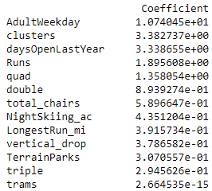 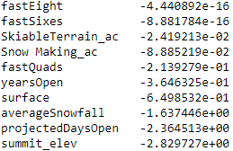

As per the above coefficients the factors which are influencing the most in positive manner are AdultWeekday (price at weekdays), clusters, daysOpenLastYear (no. of days report was open in the last year) and Runs (no. of runs of lifts). Out of these we can change only AdultWeekday and Runs.

# **Final Recommendations**

* As per the features of Big Mountain Resort, the optimum price for a ticket of an adult at a typical weekend can be around $103 instead of $81.
* The price can further be increased by increasing the price of ticket for weekdays also and by increasing the number of runs but too much increasing the price is always having the risk of decrease in number of potential tourists.
* The days projected to open the resort this season negatively impact the price and intuitively it is also not advisable to open the resort for less number of days.
* Another important aspect can be to keep the price of ticket same but increase the number of tourists and in turn increase the revenue. However this aspect needs a detailed analysis separately.